FL-01: Draw the Path – Portfolio Sitemap + Toolkit
Name: Sibgha Mursaleen
Date: 12 June 2026

One Action
I want potential clients to view my work and contact me to hire me for frontend web development projects.
Proof Statement
I help early-stage SaaS and AI founders launch their first professional landing page, creating a polished and credible online presence that builds trust from the customer's first impression.
Change after Claude's feedback
I refined my sitemap by making it more focused on early-stage SaaS and AI founders. I will structure my project pages around the problem, solution, and design decisions instead of only showing screenshots. I will also include a clear "Message Me" call-to-action on every project page.

Portfolio Sitemap (FigJam)
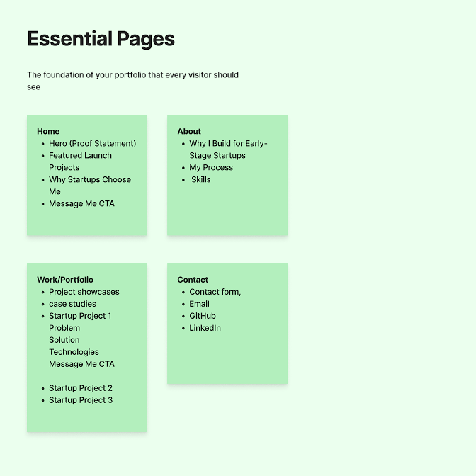

Claude Project Screenshot
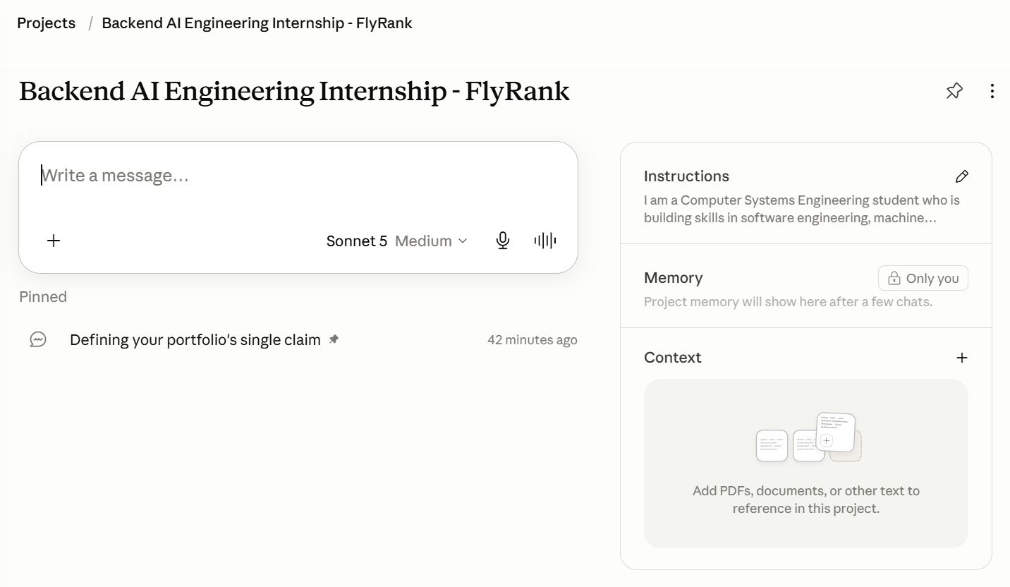

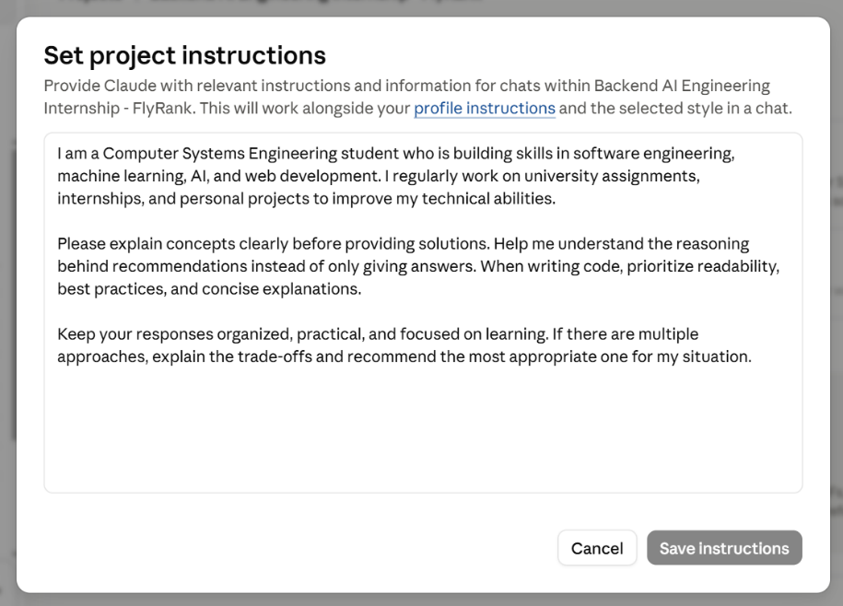

Pressure-Test Prompt & Output
